**AWS codecommit:**

AWS CodeCommit is a highly scalable, managed source control service that hosts private Git repositories. You simply create a repository to store your code. There is no hardware to provision and scale or software to install, configure, and operate. CodeCommit helps you collaborate on code with pull requests, branching, and merging. You can implement workflows that include code reviews and feedback by default, and control who can make changes to specific branches.

## Collaboration

AWS CodeCommit is designed for collaborative software development. You can easily commit, branch, and merge your code allowing you to easily maintain control of your team’s projects. CodeCommit also supports pull requests, which provide a mechanism to request code reviews and discuss code with collaborators. You can create a repository from the AWS Management Console, AWS CLI, or AWS SDKs and start working with the repository using Git.

## Encryption

You can transfer your files to and from AWS CodeCommit using HTTPS or SSH, as you prefer. Your repositories are also automatically encrypted at rest through AWS Key Management Service (AWS KMS) using customer-specific keys.

## Access Control

AWS CodeCommit uses AWS Identity and Access Management to control and monitor who can access your data as well as how, when, and where they can access it. CodeCommit also helps you monitor your repositories via AWS CloudTrail and AWS CloudWatch.

## High Availability and Durability

AWS CodeCommit stores your repositories in Amazon S3 and Amazon DynamoDB.  Your encrypted data is redundantly stored across multiple facilities. This architecture increases the availability and durability of your repository data.

## The repositories you need, when you need them

AWS CodeCommit allows you to create up to 1,000 repositories by default, and additional repositories up to 25,000 by request. You can store and version any kind of file, including application assets such as images and libraries alongside your code. It’s easy to create repositories when you need them, and delete them when you’re done.

## Easy Access and Integration

You can use the AWS Management Console, AWS CLI, and AWS SDKs to manage your repositories. You can also use Git commands or Git graphical tools to interact with your repository source files. AWS CodeCommit supports all Git commands and works with your existing Git tools. You can integrate with your development environment plugins or continuous integration/continuous delivery systems.

## Notifications and Custom Scripts

You can now receive notifications for events impacting your repositories. Notifications will come in the form of Amazon SNS notifications. Each notification will include a status message as well as a link to the resources whose event generated that notification. Additionally, using AWS CodeCommit repository triggers, you can send notifications and create HTTP webhooks with Amazon SNS or invoke AWS Lambda functions in response to the repository events you choose.

AWS CodeCommit allows you to create up to 1,000 repositories by default, and additional repositories up to 25,000 by request. You can store and version any kind of file, including application assets such as images and libraries alongside your code. It’s easy to create repositories when you need them, and delete them when you’re done.

## Easy Access and Integration

You can use the AWS Management Console, AWS CLI, and AWS SDKs to manage your repositories. You can also use Git commands or Git graphical tools to interact with your repository source files. AWS CodeCommit supports all Git commands and works with your existing Git tools. You can integrate with your development environment plugins or continuous integration/continuous delivery systems.

## Notifications and Custom Scripts

You can now receive notifications for events impacting your repositories. Notifications will come in the form of Amazon SNS notifications. Each notification will include a status message as well as a link to the resources whose event generated that notification. Additionally, using AWS CodeCommit repository triggers, you can send notifications and create HTTP webhooks with Amazon SNS or invoke AWS Lambda functions in response to the repository events you choose.

**We can create compare and pull request from one branch to another as mentioned below.. and the files to be copied branch should be destination branch**

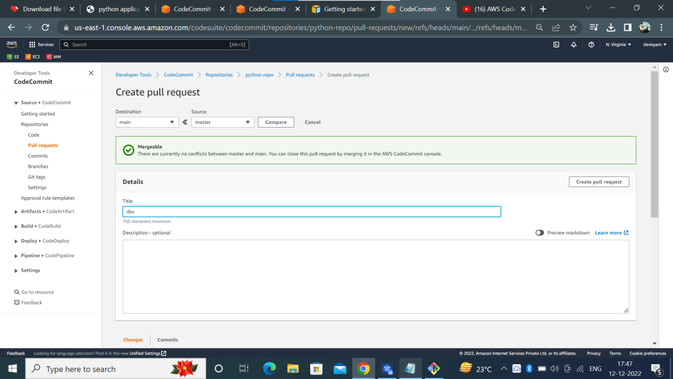

**We can merge our branch in 3 different strategies as mentioned below..**

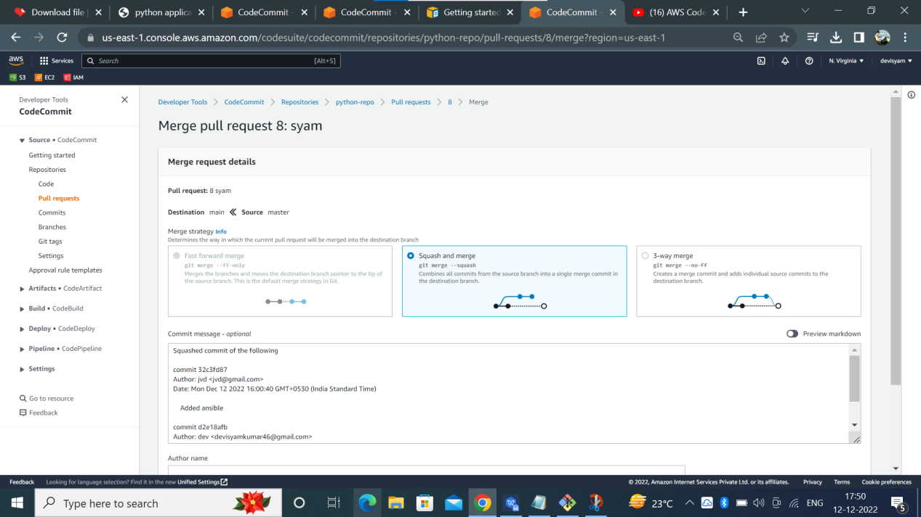

To connect aws code commit from ssh tool like git bash or cygwin ,we have to create aws iam user and specify the ec2 codecommit full access not only for code commit. if we want to use any aws services through cli or ssh we have to specify that service role to user then only we can access that service as mentioned below.. after that go to iam user security credential here you have to activate https protocol then you will get https user password credentials ..now you can clone any codecommit repository with these credentials

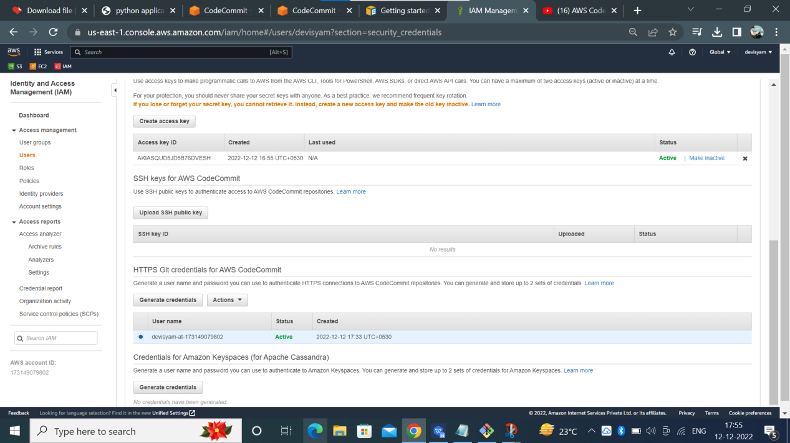

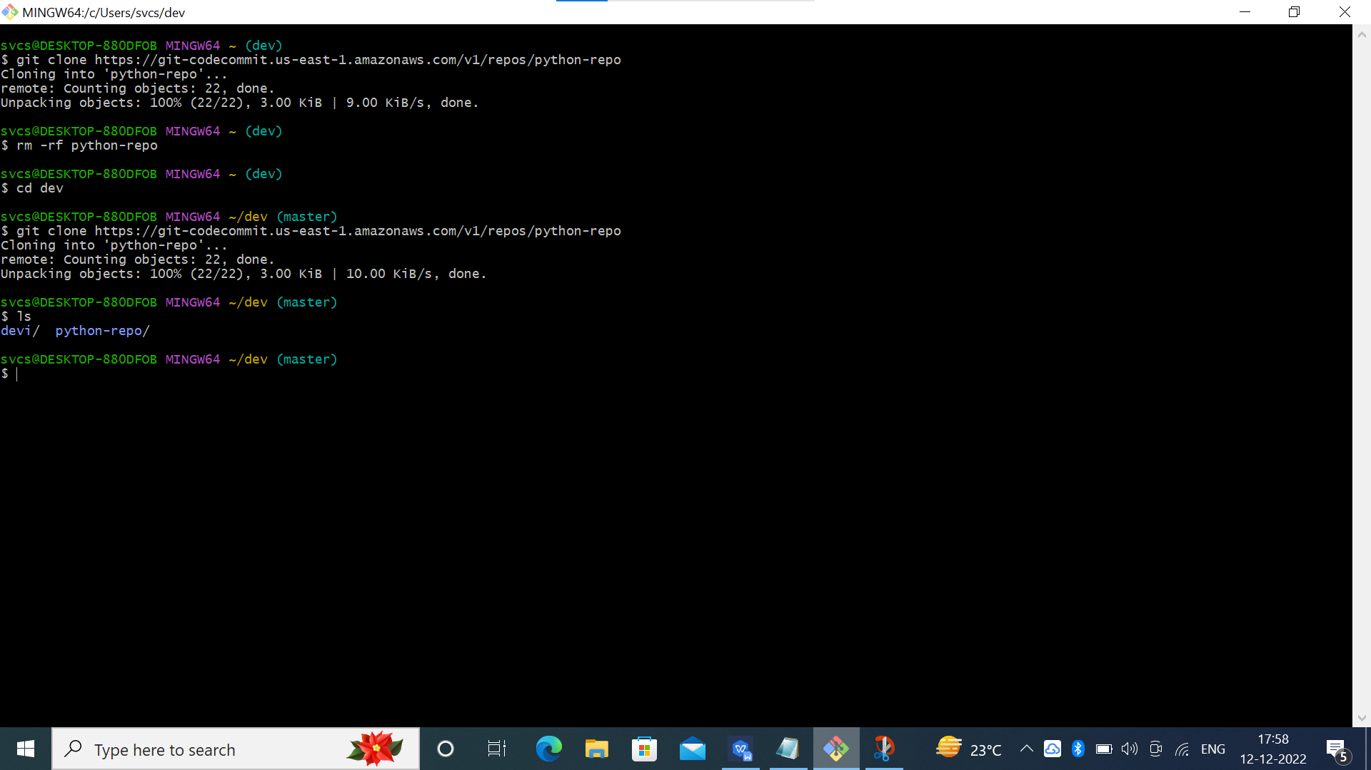

After cloning the repository you can add files into the repository after commiting all files to git you can push the repository into the aws codecommit as mentioned below..

